|  |  |
| --- | --- |
| Sales, Quantity and Profit by Segment  51.5  %  %  51.7  %  51.1  %  30.3  30  %  %  30.1  %  18.3  18.3  %  %  18.9  Consumer  Corporate  Home Office  0  1,000,000  2,000,000  3,000,000  4,000,000  5,000,000  6,000,000  7,000,000  V  a  l  u  e  s  Measures  Sales  Quantity  Profit  Segment |  |

|  |  |
| --- | --- |
|  |  |
| Sales by Order Priority  Low | 567,825.93 (4.5%)  Critical | 986,235.46 (7.8%)  High | 3,807,548.14 (30.1%)  Medium | 7,280,892.37 (57.6%)  Sales by Market  6.2  %  6.4  %  17.1  %  18.2  %  %  23.2  28.4  %  Market  Canada  Africa  EMEA  LATAM  US  EU  APAC |

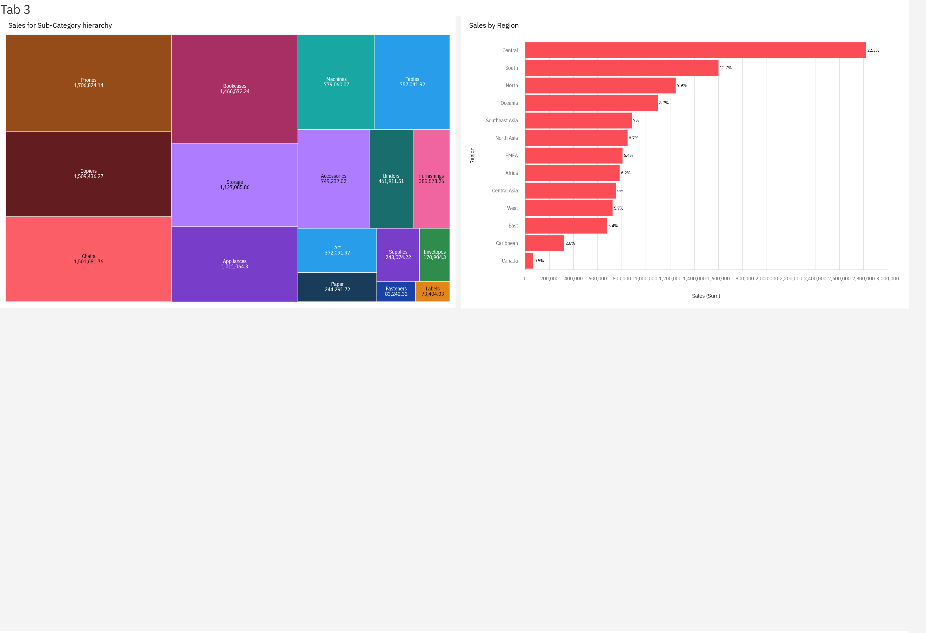

|  |  |
| --- | --- |
| Tab 4 |  |
| Country Wise Sales using MAP Points  [x](https://www.mapbox.com/about/maps/)  © Mapbo    [p](https://www.openstreetmap.org/about/)  © OpenStreetMa  Sales (Sum)  40.23  925,235.85  Region  Africa  South  Central  Southeast Asia  Caribbean  North  EMEA  North Asia  East  Oceania  Central Asia  West  Canada |

|  |  |
| --- | --- |
| Tab 5 |  |
| Profit and Sales by Sub-Category |

|  |  |
| --- | --- |
| Tab 6 |  |
|  |

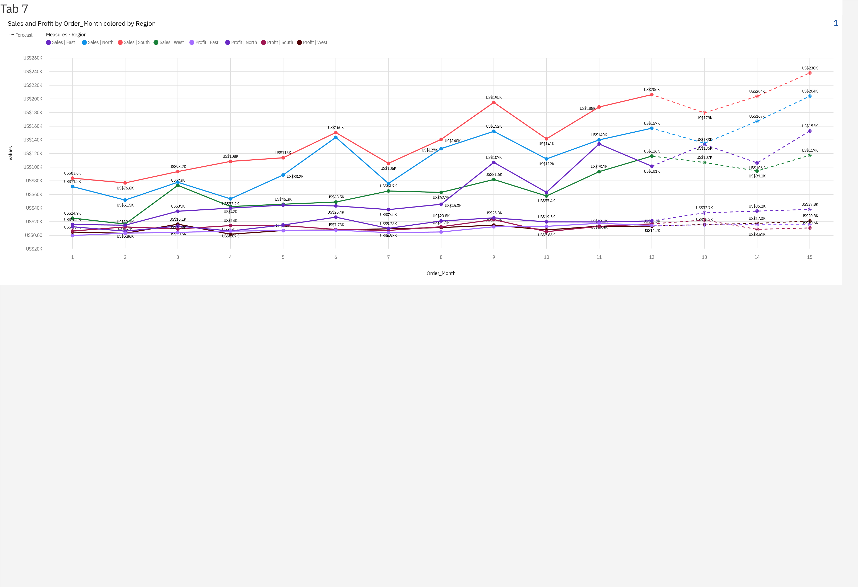

|  |
| --- |
| **Filter(s) applied to the visualization(s) on the previous page:**  **Widget 1**  Region Includes: North, West, South, East |

|  |  |  |  |
| --- | --- | --- | --- |
| Tab 8 | |  |  |
| |  | | --- | | Search | | Critical | | High Low  Medium | |  |   Sales and Profit by Order_Month Order Priority  V  a  l  u  e  s | | 1 |
| Apply | Order_Month |
|  |

|  |
| --- |
| **Filter(s) applied to the visualization(s) on the previous page:**  **Widget 1**  Order Priority Includes: Critical |

|  |  |  |
| --- | --- | --- |
| Tab 9 | |  |
| S  a  l  e  s    (  S  u  m  ) | Sales By Sub Category    Sub-Category |
|  | |

|  |  |
| --- | --- |
| Tab 10 |  |
|  |

|  |  |
| --- | --- |
| Tab 11 |  |
|  |

|  |
| --- |
| **Filter(s) applied to the visualization(s) on the previous page:**  **Widget 1**  Sales Top 10 |

|  |  |  |  |  |  |  |  |  |  |  |  |  |  |  |  |  |
| --- | --- | --- | --- | --- | --- | --- | --- | --- | --- | --- | --- | --- | --- | --- | --- | --- |
| Tab 12 | | | |  |  |  |  |  |  |  |  |  |  |  |  |  |
| Segment  Consumer Corporate | Regional Quantity And Sales Using Radar Chart (By Category)  Home Office | Furniture |  |  |  |  |  | Office Supplies |  |  |  |  |  | Technology |  |
|  | | | | Southeast Asia  South  Oceania  North Asia | Caribbean  Central  Central Asia | Canada  EMEA | East |  | West | Southeast Asia  South  Oceania  North Asia | Caribbean  Central  Central Asia | Canada  EMEA | East |  | West  Southeast Asia  South  Oceania  North Asia | |

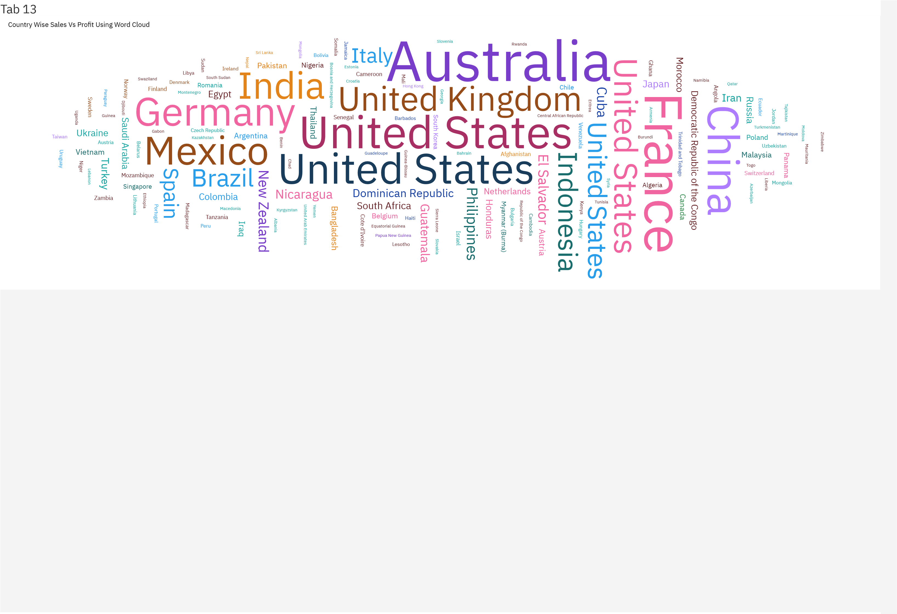

|  |  |  |  |  |  |
| --- | --- | --- | --- | --- | --- |
| Tab 14 | |  | |  |  |
| Sales  US$12.6M  Sales | | Profit  US$1.47M  Profit | Quantity  178K  Quantity | Discount  14%  Discount |
| S  u  b  -  C  a  t  e  g  o  r  y | Sales by Sub-Category   |  |  |  |  | | --- | --- | --- | --- | |  |  |  |  | |  |  |  |  | |  |  |  | US$244K  US$243K | | US$83.2K | US$17 | 1K |   Phones  Copiers  Chairs  Bookcases  Storage  Appliances  Machines  Tables  Accessories  Binders  Furnishings  Art  Paper  Supplies  Envelopes  Fasteners  Labels US$73.4K | |  |  |  |  |  |  |  |  | | --- | --- | --- | --- | --- | --- | --- | --- | |  |  |  |  |  |  |  |  | |  |  |  |  |  |  | US$1.13M |  | |  |  |  |  |  | US$1.01M | |  |  |  | US$ | 779K |  |  |  | |  |  |  | US$757K | |  |  | US$462K | US$749K | | US | $386K |  |  |  |  |  |  | | US$3 | 72K |  |  |  |  |  |  | | | US$1.71M  US$1.51M  US$1.5M  US$1.47M |
| US$0.00 US$200K | | US$400K US$600K US$800K US$1M US$1.2M  Sales (Sum) | | US$1.4M US$1.6M US$1.8M |  |
|  | | | | |